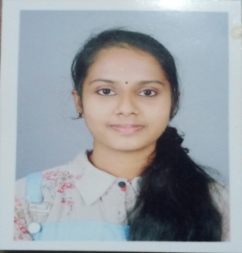 **DIYAKRISHNA T.K**

**Curriculum Vitae**

## PERSONAL DETAILS

Birth November 8,2002

Address Tee Key house cholamvayal Vatakara-1

Phone 9497869485

e-mail id diyakrishnatk@gmail.com

## EDUCATION

**BSC computer science 2020-2023**

University of calicult

Co operative arts and science college kurikkilad Vatakara

**PLUS TWO 2018-2020**

Jnm ghss puthuppanam vatakara

**SSLC 2017-2018**

St.Antony’s ghs Vatakara

## WORK EXPERIENCE

## SKILLS

Language Malayalam

English

HTML

CSS

Bootstrap

TYPING

# REFERENCE